# TABLE OF CONTENTS

**TABLE OF CONTENTS** **1**

**Climate Data** **3**

**Native Regions** **4**

**Spatial regression research** **5**

**Tree Attributes** **6**

* <https://storymaps.arcgis.com/stories/239ed577019d477894d044276a85f767>
* Created Graphs - Final Version document for the final versions of our visualizations.
  + new threshold of 20 trees and 80 birds
  + made axes more visible
  + remade diversity index geographic visualizations
  + made new plots for number of species with 10% / 20% of individuals in a cell
    - paper states that one species should not have more than 10-20% of individuals for ecosystem resilience
* Created Violin plots of the diversity indices for the bird, tree, and population bins
* Created Better Nativity plots

Fig 1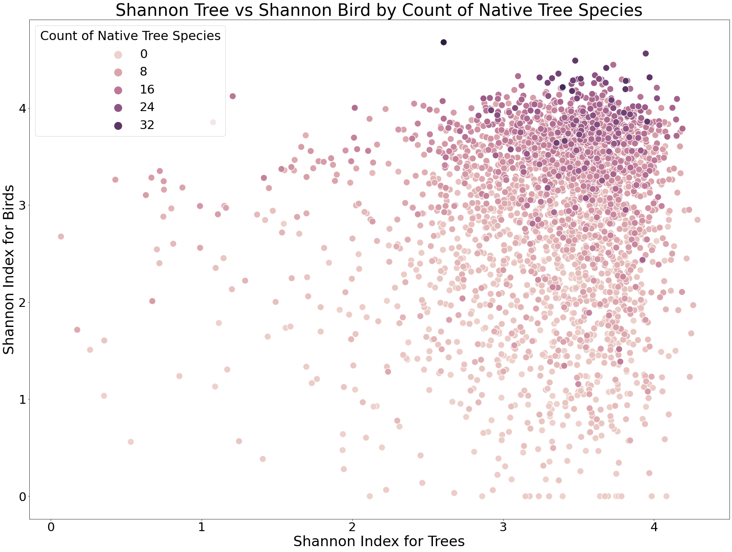

Fig 2

It is possible for there to be a high count of tree species without a high count of native to CA tree species. However, from these plots, the cells with the highest Shannon-Wiener index for birds not only have high tree species counts, but also consistently have high native tree species counts.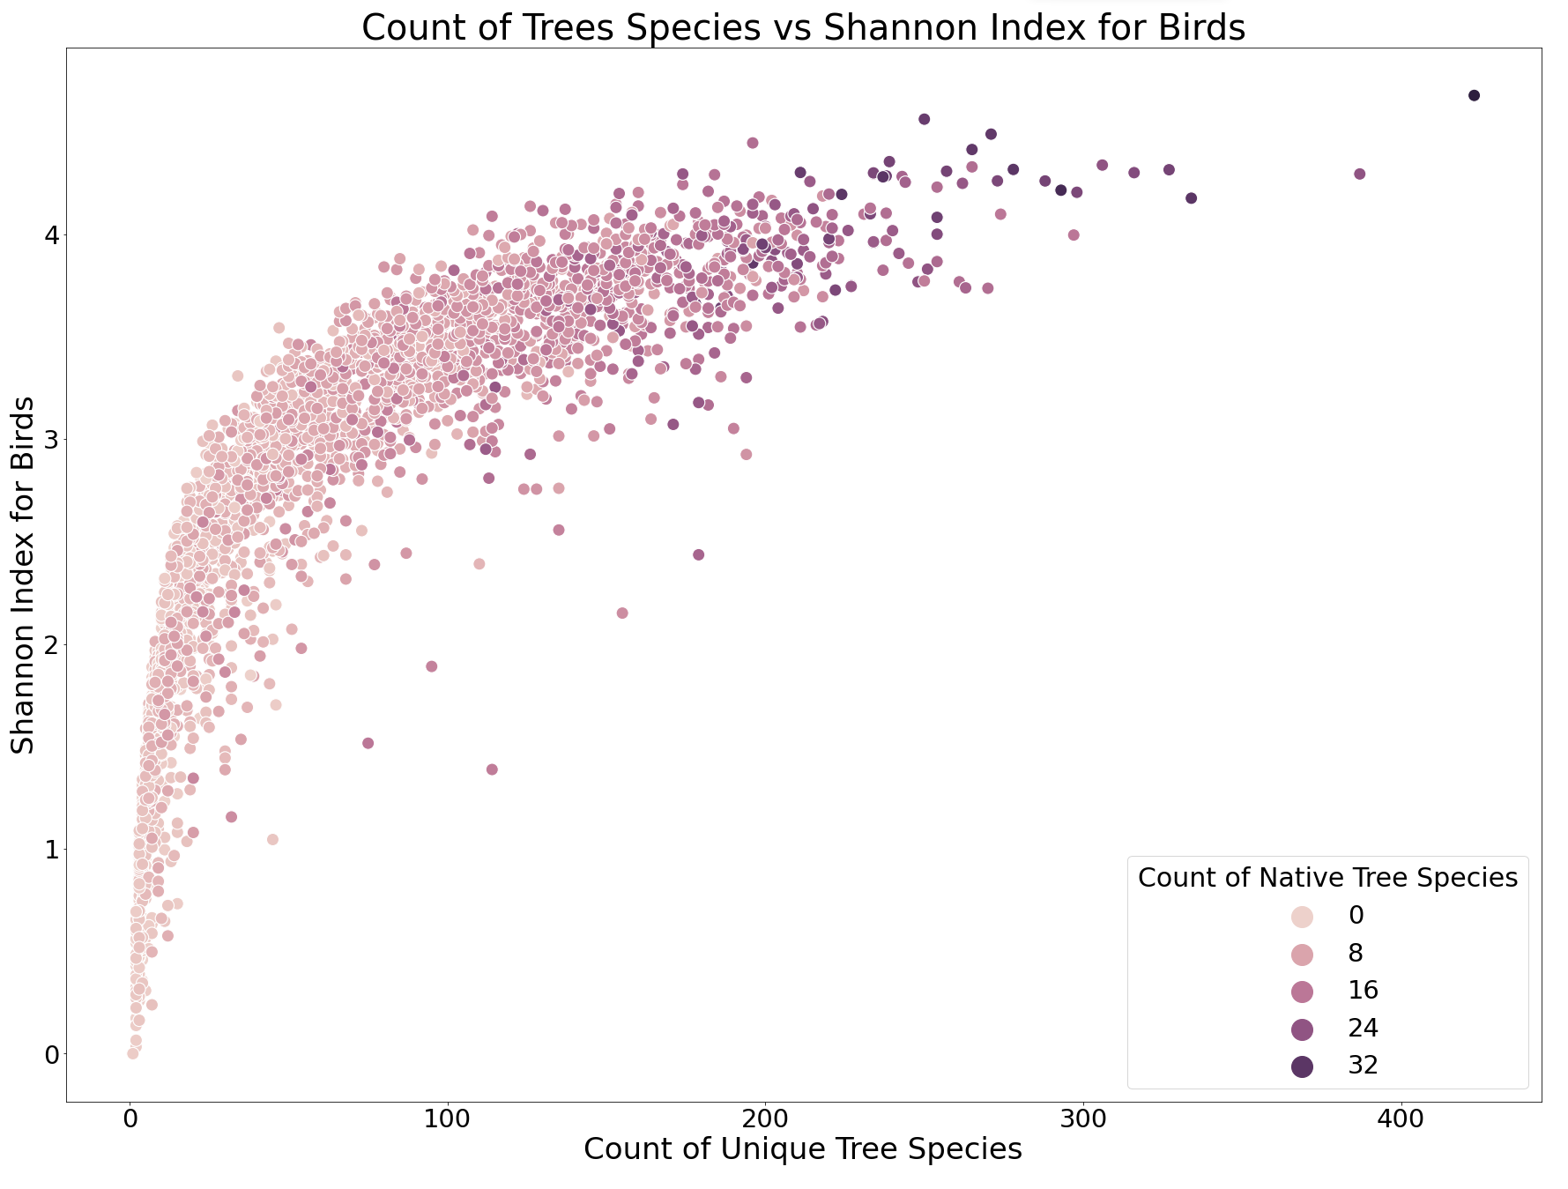

# Climate Data

<https://ca.water.usgs.gov/projects/reg_hydro/basin-characterization-model.html>

* actual evapotranspiration, potential evapotranspiration, precipitation, recharge, runoff, snowpack, temperature min, temperature max, climatic water deficit
* Point based climate data is in BigQuery, environment dataset
* data aggregated to our grid in BigQuery, treebirdagg dataset as environment
* created plots for all in Graphs - Final Version document
* Dropping variables recharge, runoff, and snowpack because they are all 0, contain no information
* ex for climatic water deficit below

Fig 3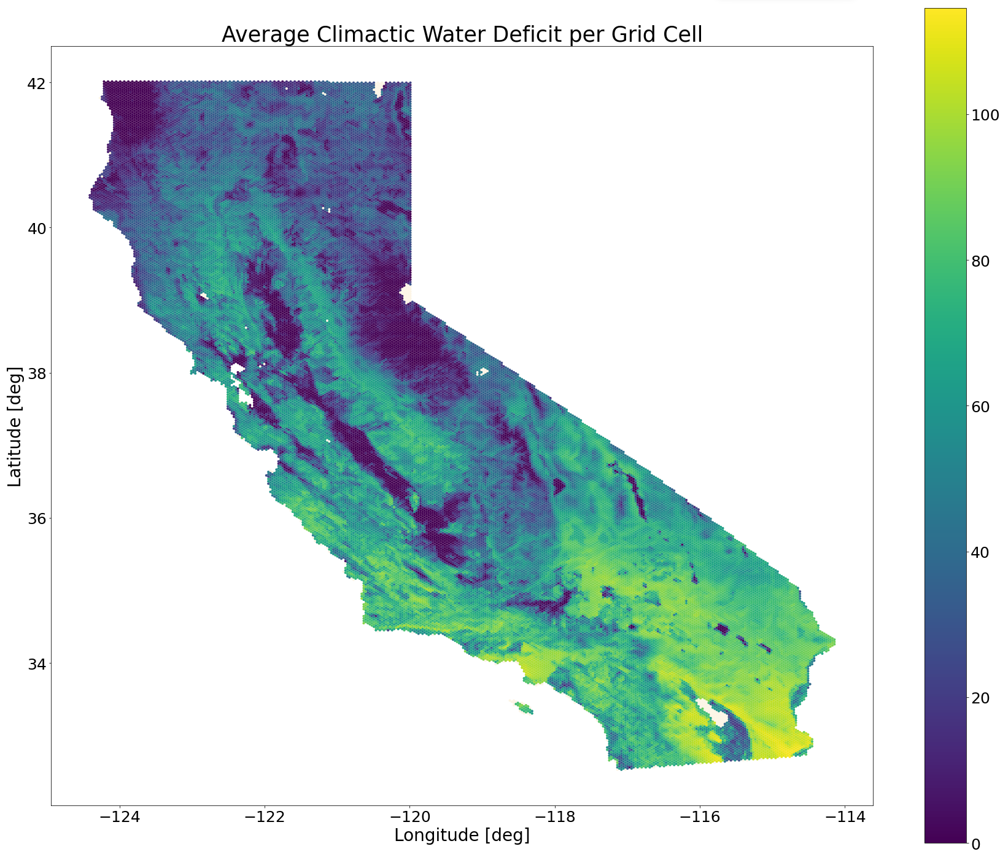

# Native Regions

Received tree native regions data from Natalie Love

* Added into Bigquery urbanforest dataset
* Converted to epsg:4326 / WGS84, Lat/Lon CRS
* Will merge into final-with-grid table as an indicator variable for each tree observation
* tree species names conflicts again

NATIVE DATA SET -> TREE DATASET

* Hesperocyparis sargentii -> Cupressus sargentii
* Celtis reticulata -> Celtis laevigata var. Reticulata
* Lyonothamnus floribundus -> Lyonothamnus floribundus subsp. aspleniifolius
* Picea stichensis -> Picea sitchensis
* Pinus jefferyi -> Pinus jeffreyi
* Prunus ilicifolia -> Prunus Ilicifolia subsp. lyonii
* Quercus wizlizenii -> Quercus wislizeni
* Sequiadendron giganteum -> Sequoiadendron giganteum

NATIVE DATA SET -> TREE ATTRIBUTE DATASET

* Umbellaria californica -> Umbellularia californica
* Prunus Ilicifolia subsp. lyonii -> Prunus ilicifolia subsp. lyonii

# 

# Spatial regression research

* <https://www.tandfonline.com/doi/full/10.1080/10106049.2019.1595177>
  + Geospatial Random Forest explanation
* <https://cran.r-project.org/web/packages/SpatialML/index.html>
  + Geospatial Random Forest R package
* <https://methods.sagepub.com/dataset/howtoguide/geographically-weighted-regression-berlin-districts-2018-python>
  + GWR (Geographically Weighted Regression) in python walkthrough
* <https://deepnote.com/@siew-sook-yan/Python-Geographically-Weighted-Regression-GWR-vwNhTvvvTwe9W8iumNFSaw>
  + GWR example analysis
* <https://www.publichealth.columbia.edu/research/population-health-methods/geographically-weighted-regression#:~:text=Geographically%20weighted%20regression%20(GWR)%20is,and%20an%20outcome%20of%20interest>.
  + GWR overview
* <https://geographicdata.science/book/notebooks/11_regression.html>
  + Spatial Regression overview
  + From site that works with only geographic data

# Tree Attributes

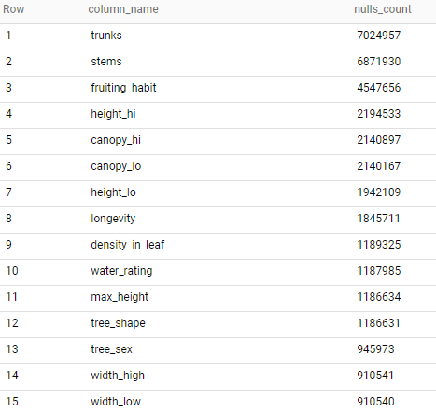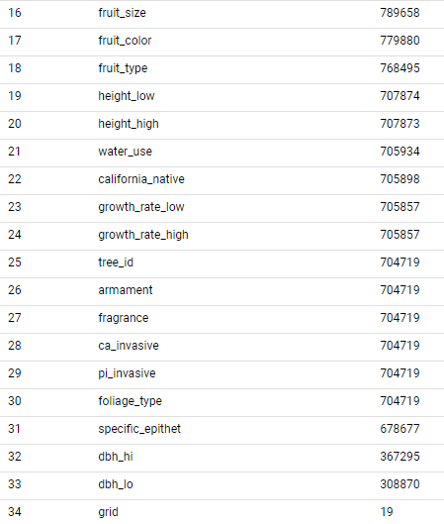

* foliage type, done
  + evergreen, deciduous, partly deciduous, percent for each
* tree sex, done
  + monoecious, dioecious, perfect flowers, percent for each
* fruiting habit, maybe
  + prolific, persistent, few, few to fruitless, fruitless, 1 - percent fruitless
* longevity, maybe
  + count of very long / very long / moderately long / average or percent
* density in leaf, done
  + count or percent of trees with very dense, dense to very dense, or dense foliage
* fragrance, done
  + 0 or 1, count fragrant trees
* fruit type, consult domain experts
  + <https://courses.botany.wisc.edu/botany_400/Lab/LabWK03Fruitkey.html>
  + <https://www2.palomar.edu/users/warmstrong/fruitid1.htm>
  + cone, edible for some birds, also used as habitat
  + fleshy cone? prob similar to cone
  + achene, indehiscent fruit, seeds, buttercup, dandelion, sunflower
  + samara, indehiscent fruit, winged twirlers, elm, maple, ash
  + nut, indehiscent fruit, chestnut, oak, hazel, walnut, some overlap with drupe
  + acorn, indehiscent fruit, nut of oaks
  + capsule, dehiscent fruit, mustard, agave, plantain, poppy
  + follicle, dehiscent fruit, larkspur, columbine
  + legume, dehiscent fruit, beans, peas, peanuts
  + drupe, fleshy fruit, peaches, plums, cherries, also walnuts, almonds, and pecans
  + pome, fleshy fruit, tough skinned, apples, pears, fleshy fruits
  + berry, fleshy fruit, berries, grape, banana, gooseberry
  + hesperidium, fleshy fruit, citrus ,watermelons, cucumbers
  + multiple fruit, from multiple flowers, mulberry, fig, pineapple, just treat as fleshy fruit
  + 768495 nulls
* one overall height var, height_high or height_low, done
* one width variable, dbh_hi or dbh_lo, average, done